Олимпиада по биологии для учителей, преподающих предмет на английском языке.
1.Match the words and pictures.
1- 2- 3-
4- 5- 6-
7- 8- 9-
a-arms b-ear c-eye d-foot/feet
e-mouth f-hands g-legs h-hair i-nose
2.Complete the sentences with a verb from the list in the correct tense.
1.Don´t be frightened of the dog. He won´t ______________.
2.Jason ____________ the boll too hard and it went over the wall into the next garden.
3.Don´t _____________ stones –you might hit somebody.
4.Mmm! Something ________delicious! Are you making a cake?
5.Can you ____________ the rice? I´m not sure if it´s cooked yet.
6.Don´t ____________ the oven door! It´s really hot.
7.In Russia if you ______________ at strangers, people think you´re mad!
8.Everybody _______________ in agreement when I explained my idea.
Key words: touch, taste, kick, nod, smell, bite, throw, smile.
3.Read the sentences. Mark the sentences T (true) or F (false).
Green plants make or produce food.__T/F_
So, we call them consumers. __T/F
Animals eat or produce food._T/F
So, we call them consumers. _T/F
Plants need oxygen to make food from simple substances. _T/F_
This process is called photosynthesis. _T/F
Green plants make oxygen at the same time as they make food. _T/F.
4. Copy and complete
Microbes break down _____________ to carbon dioxide, water and minerals. Plants use waste carbon _________________ and water for photosynthesis. Minerals are plant nutrients. So all waste is used again. We say that it is recycled.
Food chains show how food made by ____________ passes from one living thing to another. In a habitat , most plants and animals belong to more than one food _______________, so we combine food chains to form a food ________________.
5. Copy the table.
Gland | What its enzymes digest
Salivary glands | ?
Stomach lining | ?
? | No enzymes, but juice splits fats into tiny drops
Pancreas | ?, ?, ?
Small intestine lining | ?, ? ,?

6.Copy and complete the table.
Sorting vertebrates
Class | What it is like | Examples
 | Has scales, breathes through gills, lays eggs
 | Moist smooth skin, lives on land and in water, lays eggs
 | Hair covers the body, young feed on mother´s milk
 | Dry scaly skin, eggs have tough leathery shell
 | Have wings, feathers cover the body, eggs have hard shell

Key words box: crocodile, frog, cat, cod, seagull
7. Answer the question.
What does these species of nature are united? Call the cause.
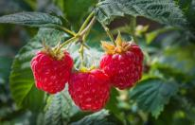 | 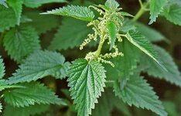 | 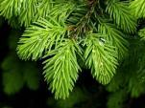
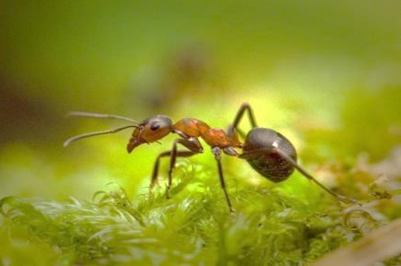 | 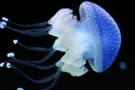 | 